# Lab: Templating

Problems for in-class lab for the ["JavaScript Applications" course @ SoftUni](https://softuni.bg/courses/js-apps).

## Contacts Book

Create a simple page containing some cards with contacts. Each card should have a **name** and a **button "Details"**. Each time the button is pressed, you have to **toggle a div** containing more detailed information about the corresponding contact.

You will be provided with the **HTML, CSS** and a **JavaScript** file with all the contacts data. You have to create a **separate template** for the contact cards and display all of them on the main page. At the end, the page should look like this:

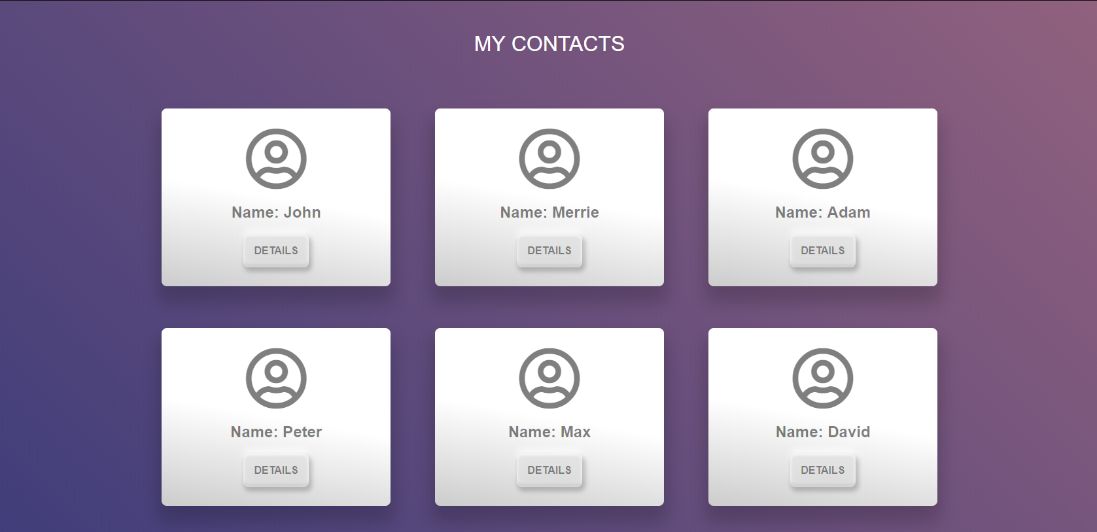

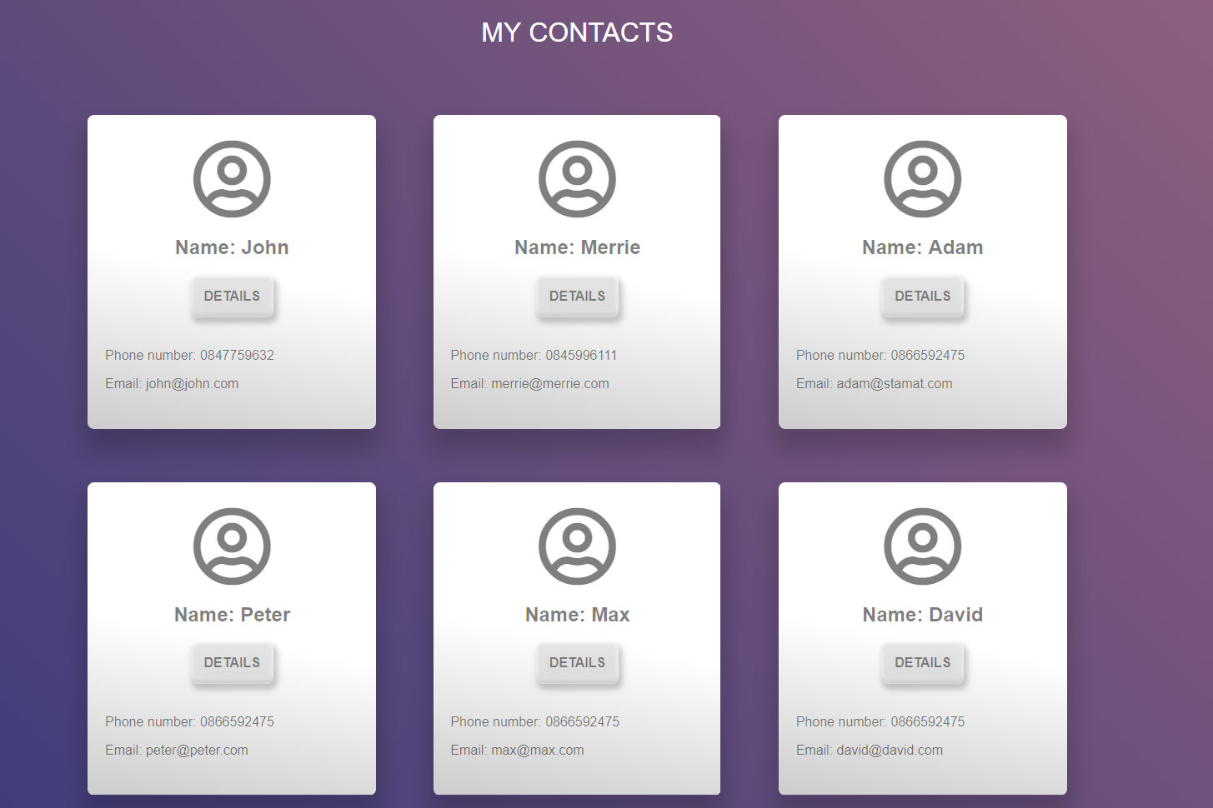

### Hints

First, create a **separate html file**, where you will put **your contact cards**:

L**oop through all the contacts** and **render the data** about each of them

The next step is to create the functionality for displaying all cards.

* Create a function that gets the **template.html** file
* Pass the contacts variable to the context
* Create the **template**
* Get the divand fill it with the **compiled HTML**
* Create the **function** that **shows** the additional info about each contact